
Common Security Module
Instance Level and Attribute Level Security
Design Document

Version No: 1.0
Last Modified: 03/24/2008

Author : Kunal Modi, Vijay Parmar
Team : Common Security Module
Purchase Order # 34552
Client : National Cancer Institute - Center for Bioinformatics,
National Institutes of Health,
US Department of Health and Human Services

Document History

Document Location
The most current version of this document is located in CVS under security/docs/CSM 4.1/development/design.

Revision History
Version Number | Revision Date | Author | Summary of Changes
0.1 | 6/21/2007 | Kunal Modi | Initial Version
0.5 | 7/01/2007 | Kunal Modi | Added Attribute Level Security
1.0 | 3/24/2008 | Vijay Parmar | Added Group Level Security Design

Review
Name | Team/Role | Version | Date Reviewed | Reviewer Comments

Related Documents
More information can be found in the following related CSM documents:

Document Name

Table of Contents

1. Introduction 4
1.1 Overview 4
1.2 Problem Scenario 4
1.3 Scope 4
2. Requirement Analysis 5
2.1 Requirements 5
2.1.1 Instance Level 5
2.1.2 Attribute Level 6
2.2 Assumptions 7
2.3 Dependencies 7
2.4 Known Issues or Future Considerations 7
2.4.1 Instance Level 7
2.4.2 Attribute Level 8
3. Detail Design 9
3.1 Instance Level Security 9
3.1.1 Overview 9
3.1.2 Class Diagram 9
3.1.3 Provisioning Changes 19
3.1.4 Runtime Integration with SDK / Non SDK Systems - User 23
3.1.5 Runtime Integration with SDK / Non SDK Systems - Groups 25
3.1.6 Database Changes 27
3.2 Attribute Level Security 31
3.2.1 Overview 31
3.2.2 Class Diagram 31
3.2.3 Provisioning Changes 35
3.2.4 Runtime Integration with SDK / Non SDK Systems – User 35
3.2.5 Runtime Integration with SDK / Non SDK Systems – Groups 38
3.2.6 Database Changes 40
4. Unit Testing 41
4.1 JUnit Test Cases 41
4.2 Test Case Scenarios 41
5. Configuration/Deployment Considerations 42
5.1 Property/Configuration Files 42
5.2 Deployment Considerations 42

Introduction

Overview
The CSM was chartered to provide a comprehensive solution to common security objectives so not all development teams need to create their own security methodology. CSM is flexible enough to allow application developers to integrate security with minimal coding effort. Going on the same philosophy there is a need to provide out of the box Instance Level as well as Attribute Level Security Solutions for client applications which would require minimal effort in integration.

Problem Scenario
Currently CSM APIs provide instance level and attribute level security. However this security is provided in the java tier. The typical flow of events in case of instance level security would be as follows. The user fires a business query on the database to obtain the resultset. Now the entire resultset is iterated through in java and for each and every record in it, a call is made to the CSM APIs to check if the user/group has access to that particular instance or not. Also in case of attribute filtering the for each of the accessible object in the resultset you need to invoke the CSM APIs to check which attributes the user can see.

In the both the solutions mentioned above, there are several issues

- The entire result set is to be returned from the database to the application resulting in network traffic and latency
- Once the resultset is obtained, it needs to be iterated through in java adding to processing time
- For each record there is a database call to CSM to determine if the user/group has access or not.

The new design should address all the performance issues mentioned above.

Scope
This document defines the detailed design for both instance (for User and Group) and attribute level security. It doesn’t provide details on how to use these features from a client application perspective. A separate document will address that.

Requirement Analysis

Requirements

Instance Level

Functional Requirements

- Direct Instance Level Security
The solution should provide Direct Instance Level Security. Direct Instance Level Security can be defined as where security for a particular instance is dependent on its own self. A user/group has access to a particular object based on the value of one of its attribute. There is no relation or association with another object. This type of instance level security is adhoc and dependant on the associations done between that instance and the user/group by security admin

For eg. Out of 456 patients in the patient table, user ABC has access to these assigned 28 based on the patient id.

Here out of the total patients in that database, the security admin has assigned 28 patient ids to the user ABC. Based on this the solution should filter any query fired on that patient table such that for that user ABC only those 28 records are accessible.

- Cross Dependant Instance Level Security
The solution should provide Cross Dependant Instance Level Security. Cross Dependant Instance Level Security can be defined as where security for a particular instance is dependent on some other object. A user/group has access to a particular object based on its association to some other higher level object on which the user/group has been granted access. There is an association with another object which is generally higher up in the data graph. This type of instance level security is based on the relationship between the queried tables to the table to which the security is assigned. This type of security is used generally where it is much easier to assigned and manage security at a higher level of data

For eg. User/Group has access only those Lab Results which are associated to the Study (via patients) on which he as access.

Here in this example there can be 1000s of Lab Results where as the Studies could be in 10s. Also as per the business rule, if you are assigned access to the Study then you can access everything associated to that study. Also in case the assignment and management of security is much easier with Studies as they are less in number.

- Solution should automatically provide Instance Level Security for an SDK generated system
Solution provided should be integrated with SDK so that it can be provided as an out of the box solution for SDK generated systems.

- Solution should provide Instance Level Security Support for a Non SDK system
The Solution provided should be adaptable for Non SDK systems with minor modifications if required. The general principle should be same as for an SDK generated system. It can be assumed that users will need to configure the solution and adapt it for their application.

Non Functional Requirements

- Load Criteria
The solution should perform with optimum load criteria. The actual size of the tables can be assumed to be around 50K to 100K with queries returning anywhere from 1K to 5K records which need to be filtered. However in case of caIntegrator there are certain tables which can hold up to a billion records due to the data warehouse nature of the application. CSM Team should evaluate if the solution can be scaled to meet such load criteria.

- Performance Criteria
There is a certain overhead in terms of time taken associated with applying security to an unsecured system. However to define these figures in terms of absolute times is not possible as it is dependent on the time taken by the actual query to execute as well as the number of records in that particular table. However this figure can be expressed in terms of percentages. Based on interactions with the caIntegrator and CTOM teams it is derived that an overhead of 10% to 20% is acceptable.

Attribute Level

Functional Requirements

- Attribute Level Security
The solution should provide Attribute level security at object level. Attribute level security can be defined as security where you can control access to the attributes of an object. A user can be granted and revoked access to these attributes. Based on the user’s/group’s access level, those attributes should be visible to the user/group or not.

For eg. A Patient object has the following five attributes Name, Address, Social Security, Phone Number and Disease. Then a researcher who has access to all the attributes except Social Security should be able to see the Patient object with all attributes except the Social Security attributed filled with data.

- Solution should work for both single or many object retrieval
The solution should provide Attribute level security both for queries which result in a single object being returned from the database as well as a list of the objects being returned from the database. In case of the list each object in the list should be filtered based attributes to which the user/group has access too.

- Solution should automatically provide Attribute Level Security for an SDK generated system
Solution provided should be integrated with SDK so that it can be provided as an out of the box solution for SDK generated systems.

- Solution should provide Attribute Level Security Support for a Non SDK system
The Solution provided should be adaptable for Non SDK systems with minor modifications if required. The general principle should be same as for an SDK generated system. It can be assumed that users will need to configure the solution and adapt it for their application.

Non Functional Requirements

- Load Criteria
The solution should perform with optimum load criteria. The actual size of the tables can be assumed to be around 50K to 100K with queries returning anywhere from 10K to 50K records which need to be filtered. The solution should be able to filter through the returned result set and also be able to scale to higher load numbers.

- Performance Criteria
There is a certain overhead in terms of time taken associated with applying security to an unsecured system. However to define these figures in terms of absolute times is not possible as it is dependent on the time taken by the actual query to execute as well as the number of records in that particular table. However this figure can be expressed in terms of percentages. Based on interactions with the caIntegrator and CTOM teams it is derived that an overhead of 10% to 20% is acceptable.

Assumptions

- Hibernate Based Solution
This design provides a solution that leverages Hibernate as a persistent framework. Hibernate is the most used framework here at NCICB as well as across caBIG. Also since EJB 3 framework closely follows Hibernate in all the provided functionality. This solution can be easily adapted for a EJB 3 based system.

Dependencies

There are no dependencies on any external projects.

Known Issues or Future Considerations

Instance Level

- In case of eager loading filtering of the child object doesn’t work
Hibernate by default inject only the filter for the parent object, so in case you have the eager loading mode set to true, the child object’s (the associated objects which are eagerly loaded) filter are not injected. SDK by default comes with eager loading set to false leaving up to the users to explicitly turn it on.

- Multiple filters on a single object will be always ANDed
If you have multiple filters defined for a single domain object, Hibernate would inject all of them with an AND conditions between them. This is the default behavior of Hibernate and would require programmatic enhancements to handle the ORing of filters

- Filtering incase of inheritance needs to be further investigated
Hibernate DTD has a limitation not allowing user to add a filter for the inherited classes. The DTD allows filters only to be added to the super class. However Hibernate API allows adding of these filters. This issue will be investigated in detail during implementation and results will be posted accordingly.

Attribute Level

- In case of eager loading the attribute filtering happens only for parent object
The onLoad method is invoked for each record returned from the database. However this works only for the parent object, so if you have eager loading set to true, the child object’s (the associated objects which are eagerly loaded) attributes aren’t filtered. SDK by default comes with eager loading set to false leaving up to the users to explicitly turn it on.

- Primitive attribute type filtering is not possible
Since a primitive data type cannot be set to null, the current attribute solution doesn’t work if the domain objects contain primitive data types as attribute. The default values for primitive (0 for int, false for a boolean) can be a valid value, hence setting primitive attributes to their default values is also not an option.

- Filtering on queries with projection on certain attributes won’t work
For queries, where the user have set a project on certain attributes of the object rather than returning the whole object back, this solution won’t work. This is because in case of projections, Hibernate returns the attribute value is directly from the database as Java data types. As a result, the onLoad method of the session interceptor is not invoked thereby not injecting the attribute level security.

Detail Design

Instance Level Security
The following section provides the detailed design for Instance Level Security

Overview
The detail design presented in this section is for Instance Level Security for User or Groups. The design discusses security for User or a set of Groups.

Class Diagram
Following is a class diagram depicting the classes that will be used to provide instance level security using CSM

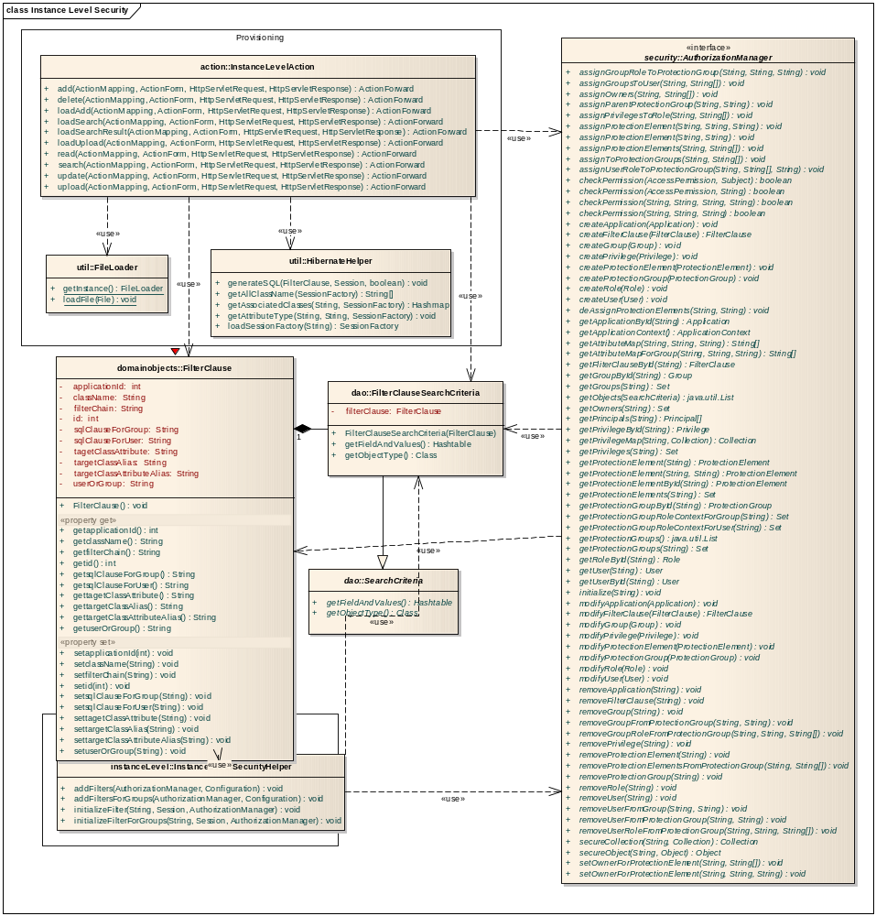

Class Name: InstanceLevelAction
Type: Class

This is a Struts Action which extends the DispatchAction. Based on the value selected by the user on the front end corresponding operation of this action is executed.This action displays all the pages to upload the jar as well as add a new filtering clause or search through old clauses

Operations
Method | Notes | Parameters
add() ActionForward  Public | This method stores the final filtering clause into the database. User selects the Class on which he wants to apply the instance level security. Now using AJAX the user navigates through the Object Graph to select the classes on which the security for that class is dependant. Once established, It obtains the generated SQL using the hibernate session and the object graph selected by the user. It stores this SQL along with other information into the database using the createFilterClause method of the Authorization Manager | HttpServletResponse response  [in]  HttpServletRequest request  [in]  ActionForm form  [in]  ActionMapping mapping  [in]
delete() ActionForward  Public | This operation deletes the Filter Clause object from the database. It invokes the removeFilterClause method of the AuthorizationManager | HttpServletResponse response  [in]  HttpServletRequest request  [in]  ActionForm form  [in]  ActionMapping mapping  [in]
loadAdd() ActionForward  Public | This method loads the page which is used to create and add new Filtering Clause for instance level security. It also checks if the Hibernate file has been loaded successfully and a Session has been created and stored in the Session or not. If not it takes user back to the Instance Level home page with appropriate message | HttpServletResponse response  [in]  HttpServletRequest request  [in]  ActionForm form  [in]  ActionMapping mapping  [in]
loadSearch() ActionForward  Public | This page loads the search criteria page. User can search for all filtering clause or the filtering clause pertaining to a particular object. | HttpServletResponse response  [in]  HttpServletRequest request  [in]  ActionForm form  [in]  ActionMapping mapping  [in]
loadSearchResult() ActionForward  Public | This operation loads the result obtained for the user's entered search criteria | HttpServletResponse response  [in]  HttpServletRequest request  [in]  ActionForm form  [in]  ActionMapping mapping  [in]
loadUpload() ActionForward  Public | This operation prepares and displays the upload page. The upload page allows the user to upload the jar containing the complete Hibernate configuration file, the domain objects and their Hibernate mapping files | HttpServletResponse response  [in]  HttpServletRequest request  [in]  ActionForm form  [in]  ActionMapping mapping  [in]
read() ActionForward  Public | This method retrieves the object which the user has selected on the search result page and displays it on the details page with all its attributes. It obtain the detailed object by calling the getFilterClauseById method of the Authorization Manager | HttpServletResponse response  [in]  HttpServletRequest request  [in]  ActionForm form  [in]  ActionMapping mapping  [in]
search() ActionForward  Public | This operation accepts the user's entered search criteria It then prepares the FilterClauseSearchCriteria object form it and invokes the getObject mehtod of the Authorizaiton Manager. It returns the resultset to the screen for user to browse | HttpServletResponse response  [in]  HttpServletRequest request  [in]  ActionForm form  [in]  ActionMapping mapping  [in]
update() ActionForward  Public | This method updates the user made changes to the filtering clause and persist them into the database. It invokes the updateFilterClause method of the Authorization Manager | HttpServletResponse response  [in]  HttpServletRequest request  [in]  ActionForm form  [in]  ActionMapping mapping  [in]
upload() ActionForward  Public | This method uploads the Hibernate file which the user has selected on his browser. It then initializes the FileLoader class and loads the jar file into the memory so that all the classes and file within it becomes available to the program. Using the passed hibernate file name, it initilializes the Hibernate Session. Once all these operations are successfully completed the control is returned to the Client. | HttpServletResponse response  [in]  HttpServletRequest request  [in]  ActionForm form  [in]  ActionMapping mapping  [in]

Class Name: FileLoader
Type: Class

This class accepts a jar file which the user has uploaded and loads it into the classpath.

Operations
Method | Notes | Parameters
Static getInstance() FileLoader  Public | Return the single instance of the FileLoader Class.
Static loadFile() void  Public | Loads the file which the user has uploaded into the current class loader. This was all the classes and files within that jar are available to the programs | File file  [in]

Class Name: HibernateHelper
Type: Class

This class aids the provisioning tools in performing all the hibernate related operations on the uploaded jar. It also acts as the server side component for all the AJAX calls from the UI.

Operations
Method | Notes | Parameters
generateSQL() void  Public | This method accepts the user's select object graph and the Class on which the filter is to be applied as well as the Alias which the user wants to used instead of the actual attributes. It now formulates a hibernate criteria using all these passed values and the Session object. It then fires the criteria on the database and traps the resulting SQL from hibernate. It then massages this SQL to formulate the WHERE Clause SQL which will be injected into the filter. The isSecurityForGroup boolean value lets the method know the kind of SQL Clause to generate for User or Group. | FilterClause [in] filterClause  Session [in] session  boolean [in] isSecurityForGroup
getAllClassName() String  Public | This methods is used by the AJAX operations to obtain a list of all the classes from the hibernate configuration | SessionFactory [in] sessionFactory
getAssociatedClasses() Hashmap  Public | This method returns the associated classes for the passed class name | String [in] className  SessionFactory [in] sessionFactory
getAttributeType() void  Public | Returns the attribute type of the passed attribute name. This will one of the possible java type of an attribute which is supported by hibernate | String [in] attributeName  String [in] className  SessionFactory [in] sessionFactory
loadSessionFactory() SessionFactory  Public | This method loads the session factory object using the hibernate file name in the memory. | String [in] hibernateFileName

Class Name: InstanceLevelSecurityHelper
Type: Class

This class helps the client application (SDK / Non SDK Generated System) to inject Instance Level Security. The client application makes the decision of either using User level or Group level security before the filters are intitialized. It use the CSM's AuthorizationManager to obtain the security Filter Clause and inject them into the Hibernate configurations supplied by the client

Operations
Method | Notes | Parameters
addFilters() void  Public | This method connects to the CSM Database and retrieves the Filter Clauses using the passed Authorization Manager. It then injects these filters into the passed Hibernate configuration object. It first creates the filter and attaches it to the configuration object. Then it also attaches this filter to the class on which the filter is to be applied. This method should be called before initializing the Session Factory. The Configuration Object returned from this method should then be used to initialize the SessionFactory by the client application | AuthorizationManager [in] authorizationManager  Configuration [in] configuration
addFiltersForGroups() void  Public | This method connects to the CSM Database and retrieves the Filter Clauses using the passed Authorization Manager. It then injects these filters into the passed Hibernate configuration object. It first creates the filter and attaches it to the configuration object. Then it also attaches this filter to the class on which the filter is to be applied. This method should be called before initializing the Session Factory. The Configuration Object returned from this method should then be used to initialize the SessionFactory by the client application | AuthorizationManager [in] authorizationManager  Configuration [in] configuration
initializeFilter() void  Public | This method initializes the filters which were added in the addfilters method. This accepts the session object and initializes all the filters in that session. It uses the list of the filter created by the addFilters method to iterate through all the filters. Once each filter is initialized it substitutes the User Name Or Group Name parameter in the filter. Now we have all the filters initialized and configured for that particular user/group. This method is to be invoked after obtaining the Session from the Session Factory and before firing the actual query. | String [in] userNameOrGroupName  Session [in] session  AuthorizationManager [in] authorizationManager
initializeFilterForGroups() void  Public | This method initializes the filters which were added in the addfilters method. This accepts the session object and initializes all the filters in that session. It uses the list of the filter created by the addFilters method to iterate through all the filters. Once each filter is initialized it substitutes the User Name Or Group Name parameter in the filter. Now we have all the filters initialized and configured for that particular user/group. This method is to be invoked after obtaining the Session from the Session Factory and before firing the actual query. | String [in] userNameOrGroupName  Session [in] session  AuthorizationManager [in] authorizationManager

Class Name: FilterClause
Type: Class

This Class stores the filter clause which the user has created. It holds the class name for which the filter is to be applied and also the hierarchy chain to the associated class on which the filter for the current Class depends. If there are any aliases to be used for the final target Class and target class attribute, then they are recorded in this class. Finally it also stores the generated Filtering SQL which will be used in the hibernate filter

Attributes
Attribute | Notes | Constraints and tags
applicationId int  Private | Holds the application id for which the filter is created | Default:
className String  Private | The class name on which the filter is to be applied | Default:
filterChain String  Private | The chain of class from the current class to the target class on which the security is dependant | Default:
id int  Private | The internal primary id associated with the filter clause | Default:
sqlClauseForGroup String  Private | The resulting SQL Clause For Group which is to be applied to the hibernate filter for that class | Default:
sqlClauseForUser String  Private | The resulting SQL Clause for Users which is to be applied to the hibernate filter for that class
tagetClassAttribute String  Private | The final class attribute name on whose value the security for the current class is dependant | Default:
targetClassAlias String  Private | The alias which is to be used for the final class on which the security for the current object is dependant | Default:
targetClassAttributeAlias String  Private | The alias which is to be used for the final class's attribute on whose value the security for the current object is dependant | Default:

Operations
Method | Notes | Parameters
Const FilterClause() void  Public | Default Constructor. Creates an empty FilterClause object
getapplicationId() int  Public | Returns the application id for which the filter is created
getclassName() String
Public
getfilterChain() String  Public | Returns the stored filter chain
getid() int  Public | Returns the primary id for this object
getsqlClause() String  Public | returns the SQL Clause for the filter
gettagetClassAttribute() String  Public | Get the Target Class Attribute Name on whose value the security is dependant
gettargetClassAlias() String  Public | Returns the alias of the target class on which the security for the current class is depenant
gettargetClassAttributeAlias() String  Public | Returns the alias of the target class's attribute on whose value the security for the current class is depenant
setapplicationId() void  Public | Sets the application id for which the filter is created | int newVal  [in]
setclassName() void  Public | Set the current class name on which the security filter is to be applied | String newVal  [in]
setfilterChain() void  Public | Set the filter hirearchy chain from the current object to the target class on which the security for current object is dependant | String newVal  [in]
setid() void  Public | Sets the primary id for this object | int newVal  [in]
setsqlClause() void  Public | Sets the SQL Clause which is to be applied in the hibernate Filter | String newVal  [in]
settagetClassAttribute() void  Public | Sets the target class attribute on whose value the security for the current class is depenant | String newVal  [in]
settargetClassAlias() void  Public | Sets the alias for the Target Class | String newVal  [in]
settargetClassAttributeAlias() void  Public | Sets the target class attribute's alias | String newVal  [in]

Class Name: FilterClauseSearchCriteria
Type: Class SearchCriteria

This is the Search Criteria Created for retrieving the FilterClause. It allows you to search based on the Class Name for which the filter is created. If no class name is provided it returns the filter clause for all the classes

Attributes
Attribute | Notes | Constraints and tags
filterClause FilterClause  Private | The passed FilterClause attribute which contains the user entered search criteria | Default:

Operations
Method | Notes | Parameters
Const FilterClauseSearchCriteria()  Public | This constructor accepts a FilterClauseObject which contains the user entered search criteria. | FilterClause filterClause  [in]
getFieldAndValues() Hashtable  Public | Returns the value of the user entered search criteria from the FilterClause
getObjectType() Class  Public | Returns the Type of the object this search criterion is holding. In this case it will return FilterClause

Class Name: AuthorizationManager
Type: Interface

A new method will be added to the AuthorizationManager to support the new Instance Level security design as shown below.

Operations
Method | Notes | Parameters
createFilterClause() FilterClause  Public | Persists the passed Filter Clause object into the database | FilterClause filterClause  [in]
getFliterClauseById() FilterClause  Public | This method returns the FilterClause object from the database for the id provided. | String filterClauseId  [in]
modifyFilterClause() FilterClause  Public | This method updates the FilterClause object in the database | FilterClause filterClause  [in]
removeFilterClause() void  Public | Removes the Filter Clause object from the database for the passed id. | String filterClauseId  [in]

Provisioning Changes
A new menu tab will be visible to the admins when they log into an application on the UPT. This tab lets them configure the filter clauses for various classes in their application. Once the filtering clauses are configured then the admins can create Protection Elements for the Instances of Objects on which the /groups have access and assign them access. The following activity diagram shows how the new menu tab for adding the filter clause would operate.

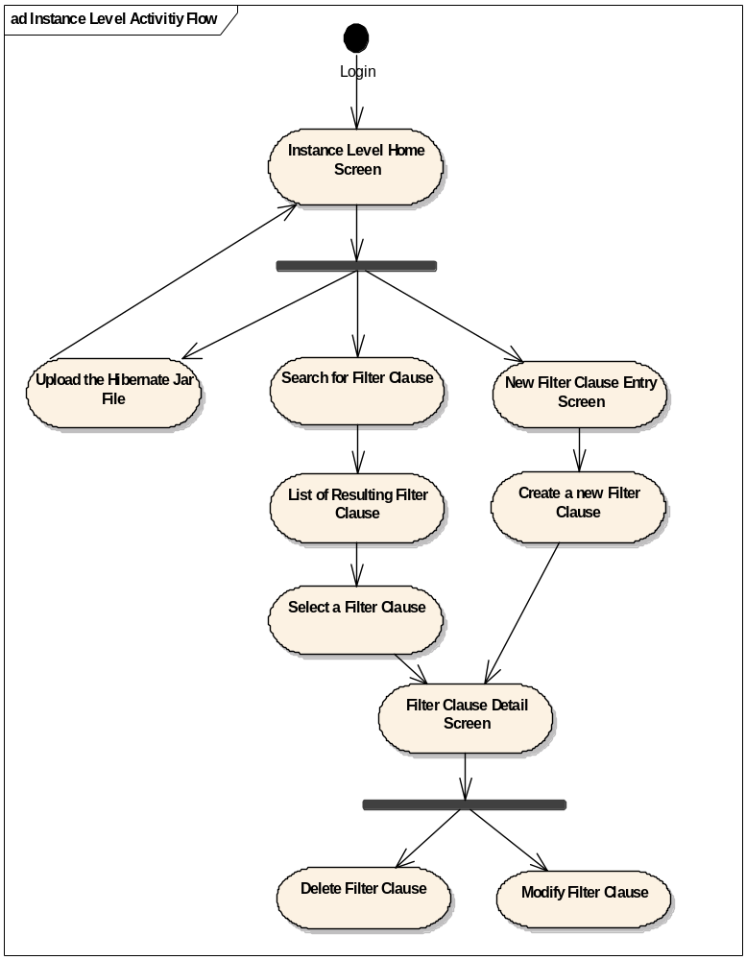

Following sequence diagram depicts the sequence of events which for the following scenarios

  - Uploading a Jar File
  - Adding a new Filter Clause

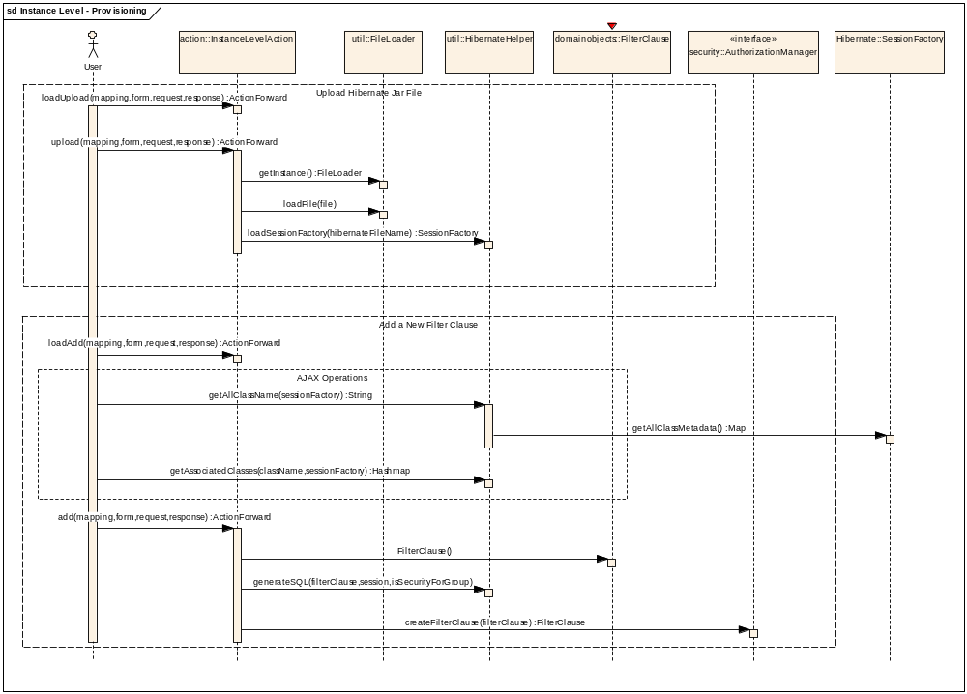

Connections
Connector | Source | Target | Notes
Sequence loadUpload(ActionMapping, ActionForm, HttpServletRequest, HttpServletResponse)  Source -> Destination | Public  User | Public  InstanceLevelAction | This method loads the upload page for the user. This page contains a file upload control along with a text box for the user to enter the fully qualified file name of the hibernate file. The user should upload a file containing the following1. Hibernate Configuration File (fully complete with the valid database connection information)2. Hibernate Mapping Files for the domain objects correctly mapping them to the database3. Domain Objects.
Sequence upload(ActionMapping, ActionForm, HttpServletRequest, HttpServletResponse)  Source -> Destination | Public  User | Public  InstanceLevelAction | Uploads the jar file containing the Hibernate configurations and domain objects from the client browser onto the server
Sequence getInstance()  Source -> Destination | Public  InstanceLevelAction | Public  FileLoader | This method returns the singleton instance of hte FileLoader class
Sequence loadFile(File)  Source -> Destination | Public  InstanceLevelAction | Public  FileLoader | This methods loads the uploaded jar file into the classpath at runtime
Sequence loadSessionFactory(String)  Source -> Destination | Public  InstanceLevelAction | Public  HibernateHelper | Now using the user entered hibernate file name and the user's jar file loaded in the memory, obtain the hibernate session factory
Sequence loadAdd(ActionMapping, ActionForm, HttpServletRequest, HttpServletResponse)  Source -> Destination | Public  User | Public  InstanceLevelAction | This method loads a page to add new filter clauses for an class. The screen flow is as decribed below:1. It allows the user to first select the class for which the filter is to be applied from the list of available classes 2. Now using AJAX it obtains the list of associated classes for the selected class allowing user to select the next class3. It repeats step two till the user has reached the target class on which the security for the class selected in step 1 depends.4. Now it lets the user selected the attribute of the target class on whose value the security depends for the original class.5. Incase the target class and attribute names have alias which are to be used at the time of provisioning, it allows the user to enter the same6. It then lets the user persist the filter clause into the database
Sequence getAllClassName(SessionFactory)  Source -> Destination | Public  User | Public  HibernateHelper | This method returns all the class names from the Session Factory. This method is invoked only once at the initial load of the page
Sequence getAssociatedClasses(String, SessionFactory)  Source -> Destination | Public  User | Public  HibernateHelper | This method returns the list associated classes for the selected class
Sequence add(ActionMapping, ActionForm, HttpServletRequest, HttpServletResponse)  Source -> Destination | Public  User | Public  InstanceLevelAction | This method takes in the user entered information and persists the same into the CSM Database. This method first tries to obtain the SQL for the user entered criteria. It then proceed to persist the user entered filter clauses with the generated SQL into the database
Sequence FilterClause()  Source -> Destination | Public  InstanceLevelAction | Public  FilterClause | This method creats a new Filter Clause object using the user entered parameters
Sequence generateSQL(FilterClause, Session)  Source -> Destination | Public  InstanceLevelAction | Public  HibernateHelper | This method takes in the user entered filter criteria and then creates a hibernate Criteria using that information. Now it fires this criteria using a dummy value and traps the generated SQL. It then calls internal method to render this SQL so tht it can be added as a filter. This SQL is added to the passed filter clause object
Sequence createFilterClause(FilterClause)  Source -> Destination | Public  InstanceLevelAction | Public  AuthorizationManager | This method persists the filter clause in the CSM Database

Runtime Integration with SDK / Non SDK Systems - User
The following sequence diagram shows how a client system (SDK / Non SDK) would integrate the instance level security for User.

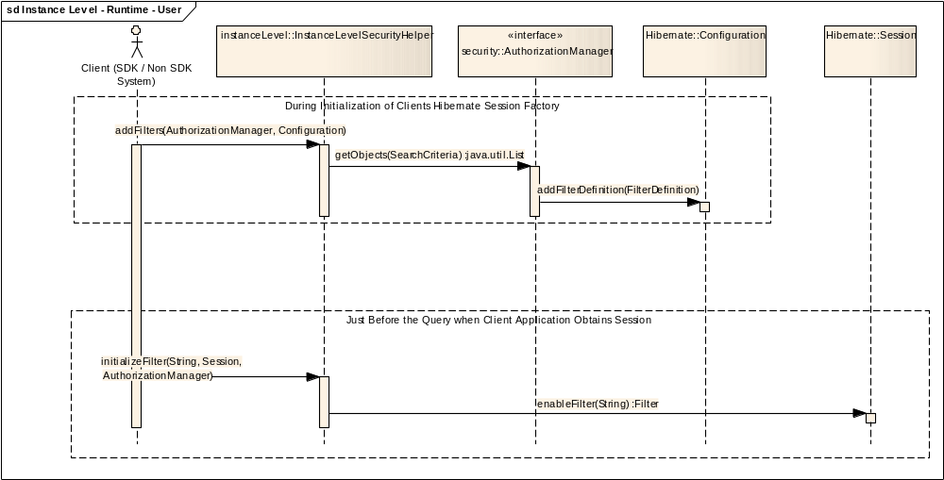
Connections
Connector | Source | Target | Notes
Sequence addFilters(AuthorizationManager, Configuration)  Source -> Destination | Public  Client (SDK / Non SDK System) | Public  InstanceLevelSecurityHelper | This method adds the Filters into the hibernate configuration object passed. This method should be called before the client initializes the Hibernate Session Factory. This method retrieves all filter clause from the CSM Database and then registers them to the hibernate configuration object it also attaches them to the Class on which they should be applied. It creates the filter name using the Class Name and the Filter Clause Id. This way multiple filter can be assigned to the same class as they will have different filter name.
Sequence getObjects(SearchCriteria)  Source -> Destination | Public  InstanceLevelSecurityHelper | Public  AuthorizationManager | This method is invoked passing the blank FilterClauseSearchCriteria as a result of which all the Filter Clauses are returned from the database.
Sequence addFilterDefinition(FilterDefinition)  Source -> Destination | Public  AuthorizationManager | Public  Configuration | This method registers the filter with the Hibernate configuration object. Also parallely it obtains the Class for which the filter is to be applied using the Filter Class name and attaches the filter to that class.
Sequence enableFilter(String)  Source -> Destination | Public  InstanceLevelSecurityHelper | Public  Session | This method enables the filter.

Runtime Integration with SDK / Non SDK Systems - Groups
The following sequence diagram shows how a client system (SDK / Non SDK) would integrate the Instance level security for Groups.

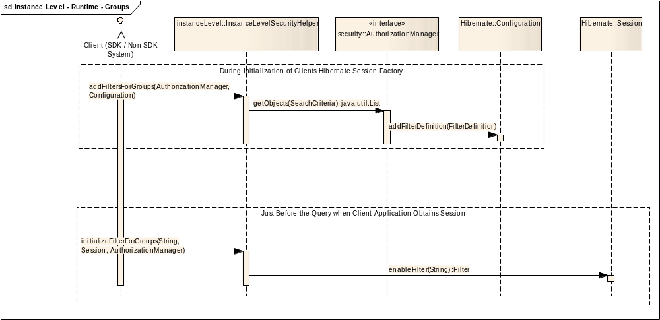

Connections
Connector | Source | Target | Notes
Sequence addFiltersForGroups(AuthorizationManager, Configuration)  Source -> Destination | Public  Client (SDK / Non SDK System) | Public  InstanceLevelSecurityHelper | This method adds the Filters into the hibernate configuration object passed. This method should be called before the client initializes the Hibernate Session Factory. This method retrieves all filter clause from the CSM Database and then registers them to the hibernate configuration object it also attaches them to the Class on which they should be applied. It creates the filter name using the Class Name and the Filter Clause Id. This way multiple filter can be assigned to the same class as they will have different filter name.
Sequence getObjects(SearchCriteria)  Source -> Destination | Public  InstanceLevelSecurityHelper | Public  AuthorizationManager | This method is invoked passing the blank FilterClauseSearchCriteria as a result of which all the Filter Clauses are returned from the database.
Sequence addFilterDefinition(FilterDefinition)  Source -> Destination | Public  AuthorizationManager | Public  Configuration | This method registers the filter with the Hibernate configuration object. Also parallely it obtains the Class for which the filter is to be applied using the Filter Class name and attaches the filter to that class.
Sequence enableFilter(String)  Source -> Destination | Public  InstanceLevelSecurityHelper | Public  Session | This method enables the filter.

Database Changes
A new table is added to hold the store the Filter Clauses. The following diagram and table describes the new table and its association to existing CSM Schema

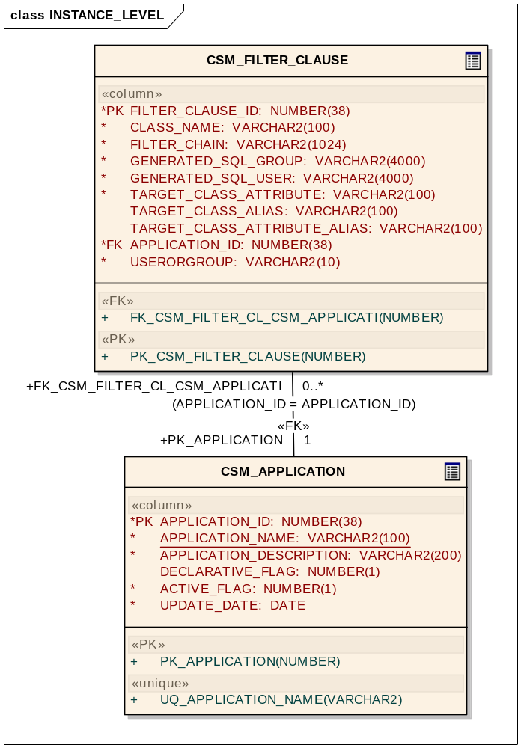

Class Name: CSM_APPLICATION
Type: Table

The application entity describes the name of the application. The authorization context is derived from application name or application context.

Connections
Connector | Source | Target | Notes
Association (APPLICATION_ID = APPLICATION_ID)  Unspecified | Public FK_CSM_GROUP_CSM_APPLICATION  CSM_GROUP | Public PK_APPLICATION  CSM_APPLICATION
Association (APPLICATION_ID = APPLICATION_ID)  Unspecified | Public FK_ROLE_APPLICATION  CSM_ROLE | Public PK_APPLICATION  CSM_APPLICATION
Association (APPLICATION_ID = APPLICATION_ID)  Unspecified | Public FK_PG_APPLICATION  CSM_PROTECTION_GROUP | Public PK_APPLICATION  CSM_APPLICATION
Association (APPLICATION_ID = APPLICATION_ID)  Unspecified | Public FK_PE_APPLICATION  CSM_PROTECTION_ELEMENT | Public PK_APPLICATION  CSM_APPLICATION
Association (APPLICATION_ID = APPLICATION_ID)  Unspecified | Public FK_CSM_FILTER_CL_CSM_APPLICATI  CSM_FILTER_CLAUSE | Public PK_APPLICATION  CSM_APPLICATION

Attributes
Attribute | Notes | Constraints and tags
ACTIVE_FLAG NUMBER  Public column | It shows if the application is active or not. | Default:
APPLICATION_DESCRIPTION VARCHAR2  Public column | In this column description of the application may be provided.e.g. what this application does and what it pertains to. | Default:
APPLICATION_ID NUMBER  Public column | It will be a sequential number. This column is the primary key for this table | Default:  [property = AutoNum=1;StartNum=1;Increment=1; ]
APPLICATION_NAME VARCHAR2  Public column | Name of the application e.g. caArray | Default:
DECLARATIVE_FLAG NUMBER  Public column | To indicate if this application uses declarative security or not. | Default:
UPDATE_DATE DATE  Public column | This column will indicate the last update of the record. | Default:

Operations
Method | Notes | Parameters
PK_APPLICATION()  Public |  | NUMBER APPLICATION_ID  [in]
UQ_APPLICATION_NAME()  Public |  | VARCHAR2 APPLICATION_NAME  [in]

Class Name: CSM_FILTER_CLAUSE
Type: Table

This table stores the Filter Clause which will be used to inject instance level security for various classes in an application. It holds the filtering criteria that is entered by the user and also the resulting SQL which should be applied to all the queries which the user enters

Connections
Connector | Source | Target | Notes
Association (APPLICATION_ID = APPLICATION_ID)  Unspecified | Public FK_CSM_FILTER_CL_CSM_APPLICATI  CSM_FILTER_CLAUSE | Public PK_APPLICATION  CSM_APPLICATION

Attributes
Attribute | Notes | Constraints and tags
APPLICATION_ID NUMBER  Public column | Holds the application id for which the filter is created | Default:
CLASS_NAME VARCHAR2  Public column | The class name on which the filter is to be applied | Default:
FILTER_CHAIN VARCHAR2  Public column | The chain of class from the current class to the target class on which the security is dependant | Default:
FILTER_CLAUSE_ID NUMBER  Public column | The chain of class from the current class to the target class on which the security is dependant | Default:
GENETRATED_SQL_GROUP  VARCHAR2  Public column | The resulting SQL Clause for Group which is to be applied to the hibernate filter for that class | Default:
GENETRATED_SQL_USER  VARCHAR2  Public column | The resulting SQL Clause for User which is to be applied to the hibernate filter for that class | Default:
TARGET_CLASS_ALIAS VARCHAR2  Public column | The alias which is to be used for the final class on which the security for the current object is dependant | Default:
TARGET_CLASS_ATTRIBUTE VARCHAR2  Public column | The final class attribute name on whose value the security for the current class is dependant | Default:
TARGET_CLASS_ATTRIBUTE_ALIAS VARCHAR2  Public column | The alias which is to be used for the final class's attribute on whose value the security for the current object is dependant | Default:
USERORGROUP VARCHAR2  Public column | The value USER or GROUP to indicate the kind of SQL Clause this record stores | Default:

Operations
Method | Notes | Parameters
FK_CSM_FILTER_CL_CSM_APPLICATI()  Public |  | NUMBER APPLICATION_ID  [in]
PK_CSM_FILTER_CLAUSE()  Public |  | NUMBER FILTER_CLAUSE_ID  [in]

Attribute Level Security
The following section provides the detailed design for Attribute Level Security

Overview
This section describes the design for Attribute Level Security for User Level or Groups Level.

Class Diagram
Following is a class diagram depicting the classes that will be used to provide attribute level security using CSM

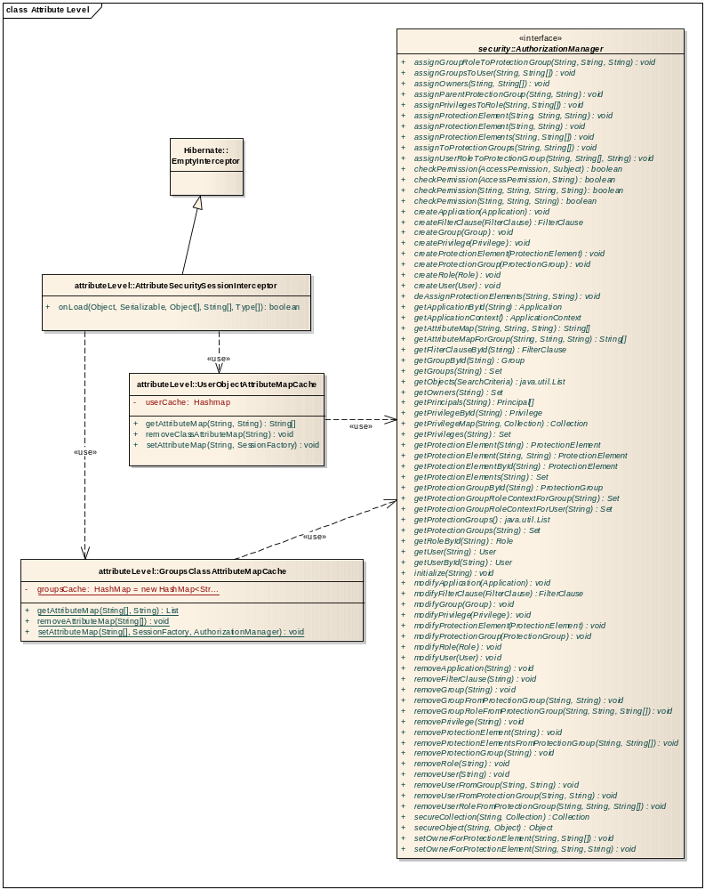

Class Name: AttributeSecuritySessionInterceptor
Type: Class EmptyInterceptor

This class intercepts the data stream returning from the database and before hibernate proceeds to create the database it filters the attribute on which the user doesnt have access.

Operations
Method | Notes | Parameters
onLoad() boolean  Public | This method is actually invoked by Hibernate whenever an object is loaded/ created in the memory. So whenever the resultset returns from the database, this method gets invoked. In case the resultset return a single object, this method is invoked once for that object. However in case the resultset returns a list of objects, this method gets invoked for each of the returning object from that resultset. This method receives the raw stream of the attributes values for that object from the underlying resultset. This method now checks whether the user or Groups haves permission on a particular attribute or not using the Attribute Map obtained and cached for the particular user or for Groups from CSM.For User - Attribute Security, In order to obtain the user name, this method will either look for ACEGI's UserDetails Object in the threadlocal variable (in case of an SDK generated system) or the User Name value directly in the threadlocal variable from ThreadVariable (in case of a NON SDK generated system).  For Groups – Attribute Security, this method will either look for Acegi’s UserDetails Object in threadlocal or Groups Name values directly in the thread local from ThreadVariableGroupInfos | Type[] types  [in]  String[] propertyNames  [in]  Object[] state  [in]  Serializable id  [in]  Object object  [in]

Class Name: UserObjectAttributeMapCache
Type: Class

This Class holds the cache containing the list of attributes for a given class for different users. The cache is organized for every user. It contains a list of the all classes and the accessible attributes on which the user has access.

Attributes
Attribute | Notes | Constraints and tags
userCache Hashmap  Private | This attributes holds the attribute cache for all the objects on which the user has access. This Hashmap contains the username as key and stores a Hashmap as value for the user. This hashmap consist of the Object Names as the key and list of accessible attributes as values. So in a way it is a three level tree with user name being the top node, followed by the list of object to which the user has access followed by the attributes of those objects on which the user has access. | Default:

Operations
Method | Notes | Parameters
getAttributeMap() String  Public | This method returns the array of accessible Attributes of the passed Class name on which the user has access. This method is invoked by the interceptor's onload method to obtain the list of the attributes the user has access on so incoming data can be filtered based on them. | String objectName  [in]  String userName  [in]
removeClassAttributeMap() void  Public | This method removes the Attribute map from the cache for the passed user name. This method should be invoked when the user logout of the system. | String userName  [in]
setAttributeMap() void  Public | This method first obtains the list of all the domain object using the passed hibernate session factory object. Now for each object name and the user name it invokes the getAttributeMap method of the Authorization Manager. It then stores the returned attribute in the internal cache hashmap. This method should be invoked when the user logs in. | SessionFactory sessionFactory  [in]  String userName  [in]

Class Name: AuthorizationManager
Type: Interface

New methods will be added to the AuthorizationManager to support the new Attribute Level security design as shown below.

Operations
Method | Notes | Parameters
getAttributeMap() String []  Public | This method returns the List of Attributes for the passed Class Name on which the user has access | String className  [in]  String userName  [in]
getAttributeMapForGroup() String []  Public | This method returns the List of Attributes for the passed Class Name on which the group have access | String className  [in]  String groupName  [in]

Provisioning Changes
There are no changes required to the existing UPT Tool for provisioning of the attribute level security. The attribute level security will be provisioned through the existing Protection Element. Protection element has a field called attribute which can hold the value of the attributes on which the user has access (the class name will be stored in the objectId attribute of it). These Protection Elements then can be assigned to the user who has rights to see those attributes

Runtime Integration with SDK / Non SDK Systems – User
The following sequence diagram shows how a client system (SDK / Non SDK) would integrate the attribute level security.

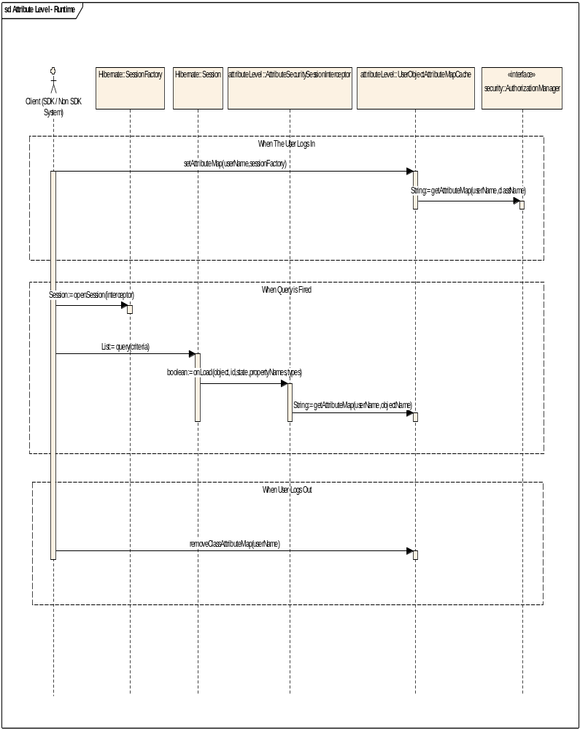

Connector | Source | Target | Notes
Sequence setAttributeMap(String, SessionFactory)  Source -> Destination | Public  Client (SDK / Non SDK System) | Public  UserObjectAttributeMapCache | When the user logs in, this method should be invoked passing the SessionFactory and the User Name. It retrieves all the domain class names from the SessionFactory and passes them one by one to obtain the Attribute Cache from the CSM Authorization Manager for that user.
Sequence getAttributeMap(String, String)  Source -> Destination | Public  UserObjectAttributeMapCache | Public  AuthorizationManager | Returns the list of Accessible Attributes by the user for the passed class name. This method is invoked for each of the class name obtained from the SessionFactory
Sequence openSession(Interceptor)  Source -> Destination | Public  Client (SDK / Non SDK System) | Public  SessionFactory | At query time, whenever the session is obtained, it should now be obtained with the AttributeSecuritySessionInterceptor attached to it.
Sequence query(Criteria)  Source -> Destination | Public  Client (SDK / Non SDK System) | Public  Session | User fires the query. This query gets executed on the database and the resultset is returned back to hibernate from the database. Now whenever a domain object is getting created from that resultset, hibernate invokes the onLoad Method of the interceptor for each of the row in the resultset.
Sequence onLoad(Type[], String[], Object[], Serializable, Object)  Source -> Destination | Public  Session | Public  AttributeSecuritySessionInterceptor | This method obtains the raw stream of data. Based on the passed username (via threadlocal) and the class name of the object being retrieved from the database, it obtains the attribute cache. Now based on the list of accessible attribute, it clears all the attributes from the data stream on which the user doesnt have access. Once it is done, it gives control back to hibernate, letting it proceed with creation of the object. This object now contains only the attributes on which the use as access
Sequence getAttributeMap(String, String)  Source -> Destination | Public  AttributeSecuritySessionInterceptor | Public  UserObjectAttributeMapCache | This method returns the list of accessible attribute for the passed user name and class name from the cache which was created at the time of user login
Sequence removeClassAttributeMap(String)  Source -> Destination | Public  Client (SDK / Non SDK System) | Public  UserObjectAttributeMapCache | This method should be invoked when the user logs out. It removes the cached attribute map for the user.

Runtime Integration with SDK / Non SDK Systems – Groups
The following sequence diagram shows how a client system (SDK / Non SDK) would integrate the attribute level security.
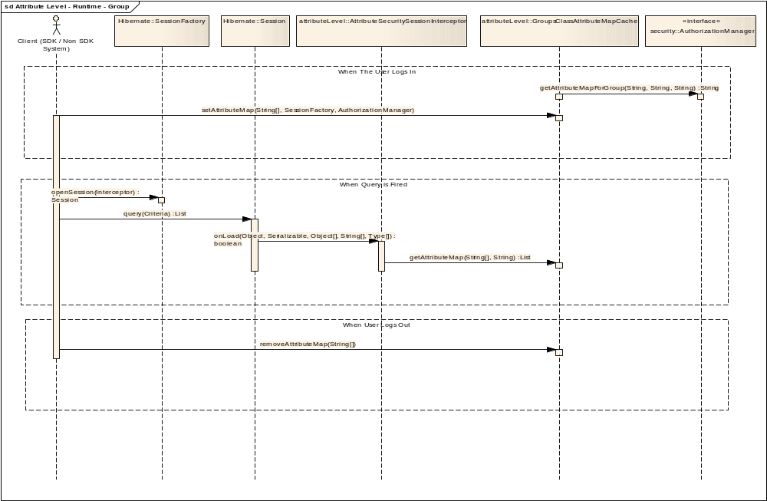

Connector | Source | Target | Notes
Sequence setAttributeMap(String, SessionFactory)  Source -> Destination | Public  Client (SDK / Non SDK System) | Public  GroupsClassAttributeMapCache | When the login occurs with Groups Names, this method should be invoked passing the SessionFactory and the name of Groups. It retrieves all the domain class names from the SessionFactory and passes them one by one to obtain the Attribute Cache from the CSM Authorization Manager for each Group.
Sequence getAttributeMap(String, String)  Source -> Destination | Public  UserObjectAttributeMapCache | Public  AuthorizationManager | Returns the list of Accessible Attributes by the Groups for the passed class name. This method is invoked for each of the class name obtained from the SessionFactory
Sequence openSession(Interceptor)  Source -> Destination | Public  Client (SDK / Non SDK System) | Public  SessionFactory | At query time, whenever the session is obtained, it should now be obtained with the AttributeSecuritySessionInterceptor attached to it.
Sequence query(Criteria)  Source -> Destination | Public  Client (SDK / Non SDK System) | Public  Session | The client application fires the query. This query gets executed on the database and the resultset is returned back to hibernate from the database. Now whenever a domain object is getting created from that resultset, hibernate invokes the onLoad Method of the interceptor for each of the row in the resultset.
Sequence onLoad(Type[], String[], Object[], Serializable, Object)  Source -> Destination | Public  Session | Public  AttributeSecuritySessionInterceptor | This method obtains the raw stream of data. Based on the passed username (via threadlocal) and the class name of the object being retrieved from the database, it obtains the attribute cache. Now based on the list of accessible attribute, it clears all the attributes from the data stream on which the group doesn't have access. Once it is done, it gives control back to hibernate, letting it proceed with creation of the object. This object now contains only the attributes on which the use as access
Sequence getAttributeMapForGroup(String, String)  Source -> Destination | Public  AttributeSecuritySessionInterceptor | Public  GroupsClassAttributeMapCache | This method returns the list of accessible attribute for the passed group name and class name from the cache which was created at the time of login
Sequence removeClassAttributeMap(String)  Source -> Destination | Public  Client (SDK / Non SDK System) | Public  GroupsClassAttributeMapCache | This method should be invoked when the user logs out. It removes the cached attribute map for the Groups.

Database Changes
There are no database changes required to the CSM Authorization Schema for Attribute Level Security. The current Protection Element table has attribute column which will hold the name of the attribute on which the user has access.

Unit Testing

JUnit Test Cases
This solution requires integration with a end user application. Also the testing of these is dependant on client applications model as well as data. As a result it is not possible to formulate automated JUnits to test these features.

Hence the team is planning to perform integration tests

Test Case Scenarios
The test case scenarios will be developed in conjunction with the QA Team. Based on the initial design the overall test scenarios are as mentioned below. Note that based on data each of these scenarios can have multiple test cases

  - Testing inherited security with n level of parents (Eg. Gene to Chromosome to Taxon)
  - Testing inherited security with 1 level of parents (Eg. Lab Result to Patient)
  - Testing direct security (Access to Patients based on assigned Patient Id)
  - Testing direct security using alias (Access to Patient based on security key column)
  - Testing of multiple filters on a given domain object.

Configuration/Deployment Considerations

Property/Configuration Files
  - The current configuration step for configuring the CSM Authorization APIs would be sufficient to support both Instance Level as well as Attribute Level Security.
  - Incase of SDK, three new properties will be added to the deployment configuration, allowing the end users to configure whether they want to enable Instance Level and Attribute Level security or not. Also to indicate whether the User Level or Group Level Security is desired.

Deployment Considerations
- All provisioning components will be packaged as part of CSM UPT. There is no special deployment requirement for either Instance Level or Attribute Level with respect to the UPT.
- All runtime components will be packaged as part of CSM APIs. Again there is no special deployment requirement for either Instance Level or Attribute Level with respect to the CSM APIs.

